**Write a program for Circular implementation of a Queue.**

#include<iostream.h>

#include<conio.h>

struct Node

{

int data;

struct Node*next;

};

Node*front=NULL;

Node*rear=NULL;

void enqueue(int val)

{

if(front==NULL||rear==NULL)

{

Node*newNode;

newNode = new Node;

newNode->data=val;

newNode->next=NULL;

front=newNode;

rear=newNode;

}

else

{

Node*newNode;

newNode=new Node;

newNode->data=val;

rear->next=newNode;

newNode->next=front;

rear=newNode;

}

}

void dequeue()

{

Node*n;

n=front;

front=front->next;

delete(n);

}

void display()

{

Node*ptr;

ptr=front;

do

{

cout<<ptr->data<<" ";

ptr=ptr->next;

}

while(ptr!=rear->next);

cout<<endl;

cout<<endl;

}

int main(void)

{

enqueue(10);

enqueue(20);

enqueue(30);

enqueue(40);

enqueue(50);

enqueue(60);

display();

dequeue();

display();

return 0;

}

**OUTPUT :-**

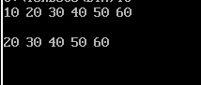

**write a progran for array implementation of a Satck.**

#include<iostream.h>

#include<conio.h>

int stack[100], n=100, top=-1;

void push(int val)

{

if(top>=n-1)

cout<<"Stack Overflow"<<endl;

else

{

top++;

stack[top]=val;

}

}

void pop()

{

if(top<=-1)

cout<<"Stack Underflow"<<endl;

else

{

cout<<"The popped element is"<<stack[top]<<endl;

top--;

}

}

void display()

{

if(top>=0)

{

cout<<"Stack element are:";

for(int i=top;i>=0;i--)

cout<<stack[i]<<" ";

cout<<endl;

}

else

cout<<"Stack is empty";

}

int main()

{

int ch,val;

cout<<"1)Push in stack"<<endl;

cout<<"2)Pop from stack"<<endl;

cout<<"3)Display stack"<<endl;

cout<<"4)Exit"<<endl;

do

{

cout<<"Enter choice:";

cin>>ch;

switch(ch)

{

case 1:

{

cout<<"Enter value to be pushed:";

cin>>val;

push(val);

break;

}

case 2:

{

pop();

break;

}

case 3:

{

display();

break;

}

case 4:

{

cout<<"Exit"<<endl;

break;

}

default:

{

cout<<"Invalid Choice"<<endl;

}

}

}

while(ch!=4);

return 0;

}

**OUTPUT** :-

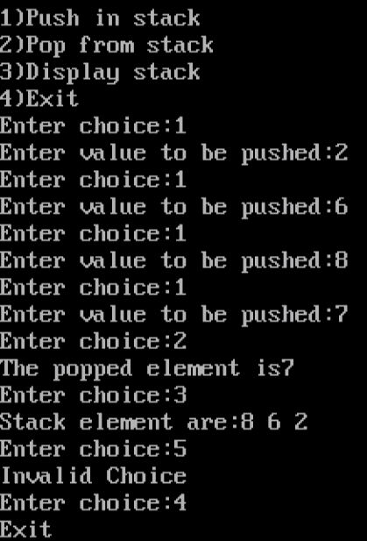

**Write a program for link list implementation of a Queue.**

#include<iostream.h>

#include<conio.h>

struct node

{

int info;

struct node*next;

};

class Queue

{

private:

node*rear;

node*front;

public:

Queue();

void enqueue();

void dequeue();

void display();

};

Queue::Queue()

{

rear=NULL;

front=NULL;

}

void Queue::enqueue()

{

int data;

node*temp=new node;

cout<<"Enter the data to enqueue:";

cin>>data;

temp->next=NULL;

if(front==NULL)

{

front=temp;

}

else

{

rear->next=temp;

}

rear=temp;

}

void Queue::dequeue()

{

node*temp=new node;

if(front==NULL)

{

cout<<"\nQueue is Empty\n";

}

else

{

temp=front;

front=front->next;

cout<<"The data Dequeue is"<<temp->info;

delete temp;

}}

void Queue::display()

{

node*p=new node;

p=front;

if(front==NULL)

{

cout<<"\n nothing to Display\n";

}

else

{

while(p!=NULL)

{

cout<<endl<<p->info;

p=p->next;

}

}

}

int main()

{

Queue queue;

int choice,true;

while(true)

{

cout<<"\n 1.Emqueue\n 2.Dequeue \n 3.Display \n 4.Quit";

cout<<"\n Enter your choice:";

cin>>choice;

switch(choice)

{

case 1:

queue.enqueue();

break;

case 2:

queue.dequeue();

break;

case 3:

queue.display();

break;

case 4:

defult:

cout<<"\n Invalid Input. Try again!\n";

break;

}

}

return 0;

}

**OUTPUT :-**

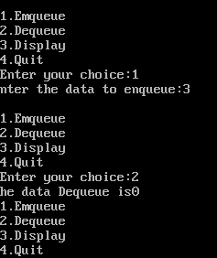

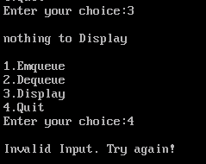

**program for the Heap Sort of array.**

**CODE :**

#include<iostream.h>

#include<conio.h>

void heapify(int arr[],int n, int i)

{

int temp;

int largest=i;

int l=2*i+1;

int r=2*i+2;

if(l<n&&arr[l]>arr[largest])

largest=l;

if(r<n&&arr[r]>arr[largest])

largest=r;

if(largest!=i)

{

temp=arr[i];

arr[i]=arr[largest];

arr[largest]=temp;

heapify(arr,n,largest);

}

}

void heapsort(int arr[],int n)

{

int temp;

int i;

for(i=n/2-1;i>=0;i--)

heapify(arr,n,i);

for(i=n-1;i>=0;i--)

{

temp=arr[0];

arr[0]=arr[i];

arr[i]=temp;

heapify(arr,i,0);

}

}

int main()

{

clrscr();

int arr[20],n;

int i;

cout<<"Enter the no. of elements:";

cin>>n;

cout<<"Enter"<<n <<"element:";

for(i=0;i<n;i++)

cin>>arr[i];

heapsort(arr,n);

cout<<"sorted array is:";

for(i=0;i<n;i++)

cout<<arr[i]<<" ";

getch();

return 0;

}

**OUTPUT :-**

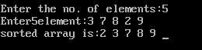

**Write a program frp Shell Sorts of array.**

**CODE :**

#include<iostream.h>

#include<conio.h>

void shellsort(int arr[],int n)

{

for(int gap=n/2;gap>0;gap/=2)

{

for(int i=gap;i<n;i++)

{

int temp=arr[i];

int j;

for(j=i;j>=gap&&arr[j-gap]>temp;j-=gap)

{

arr[j]=arr[j-gap];

}

arr[i]=temp;

}

}

}

void main()

{

int arr[20],n;

int i;

cout<<"\n Enter the number of elements:";

cin>>n;

cout<<"Enter"<<n<<"element:<<endl;

for(i=0;i<n;i++)

cin>>arr[i];

cout<<"sorted array:";

for(i=0;i<n;i++)

cout<<arr[i]<<" ";

getch();

}

**OUTPUT :-**

